IBM ASSIGNMENT-I

(Personal Assistance for Seniors who are Self-Reliant)

Submitted by

R.DEVIKA

9629171529

CIRCUIT CONNECTION MADE

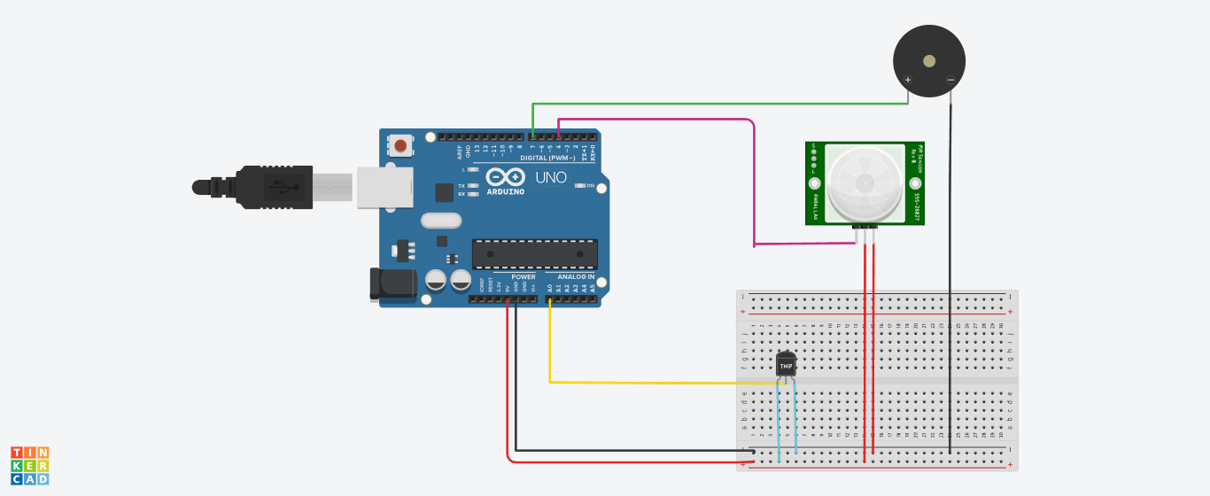

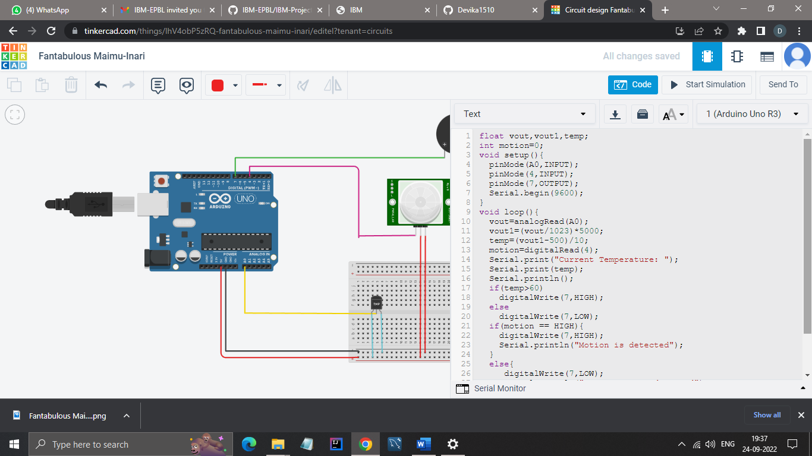

OUTPUT RECEIVED

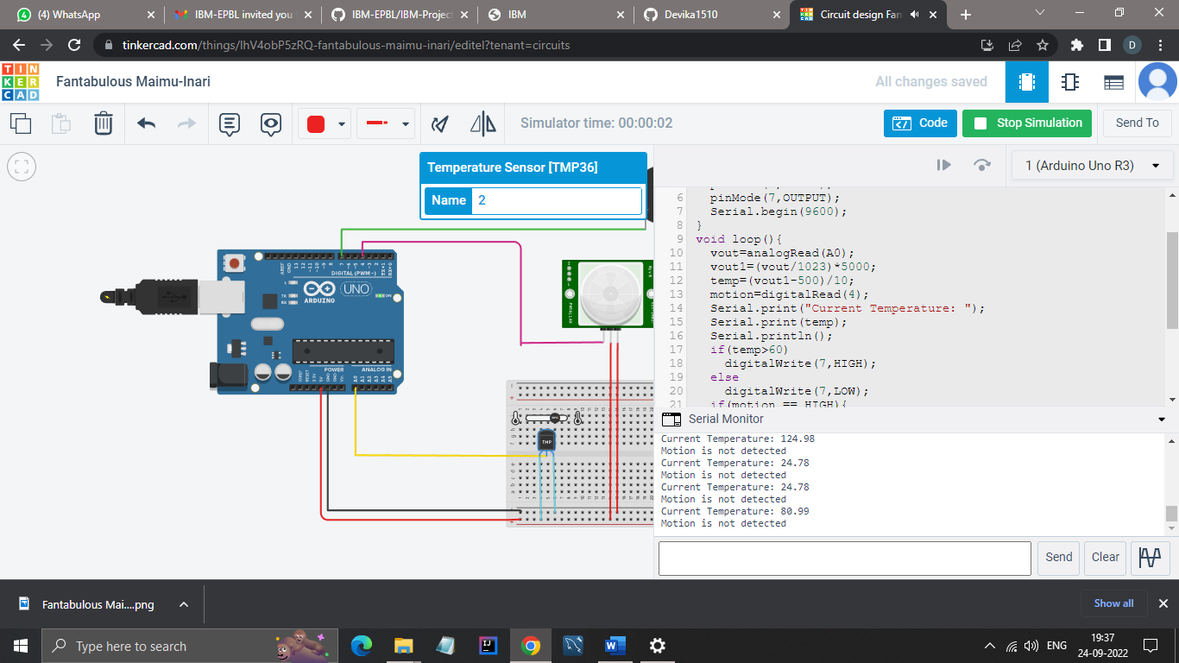

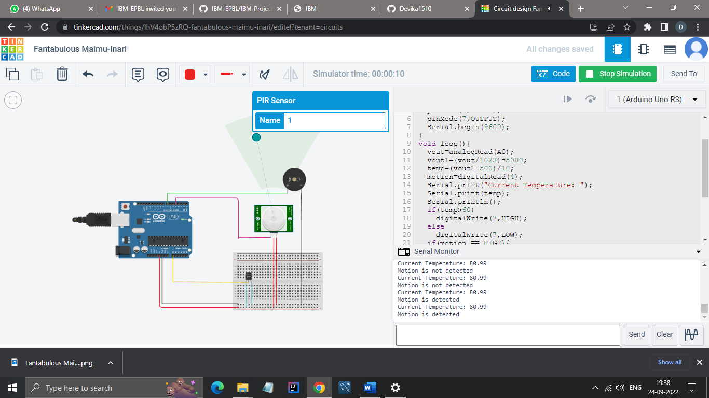

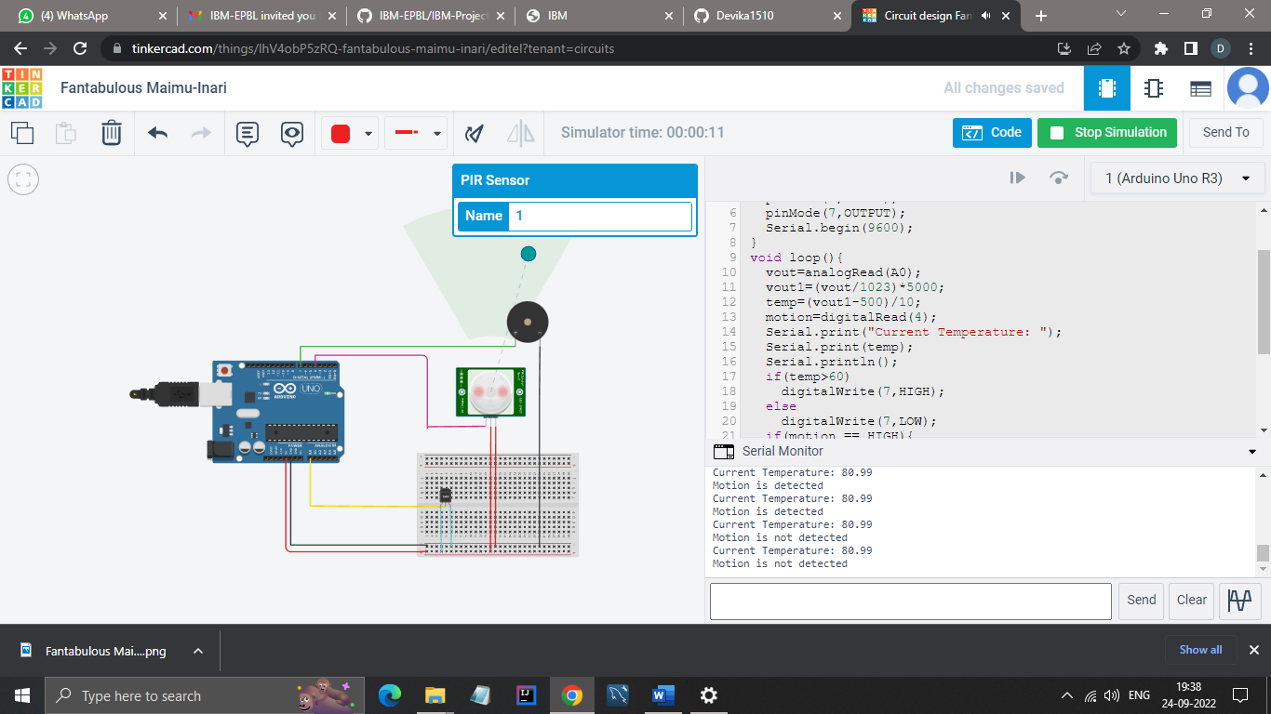

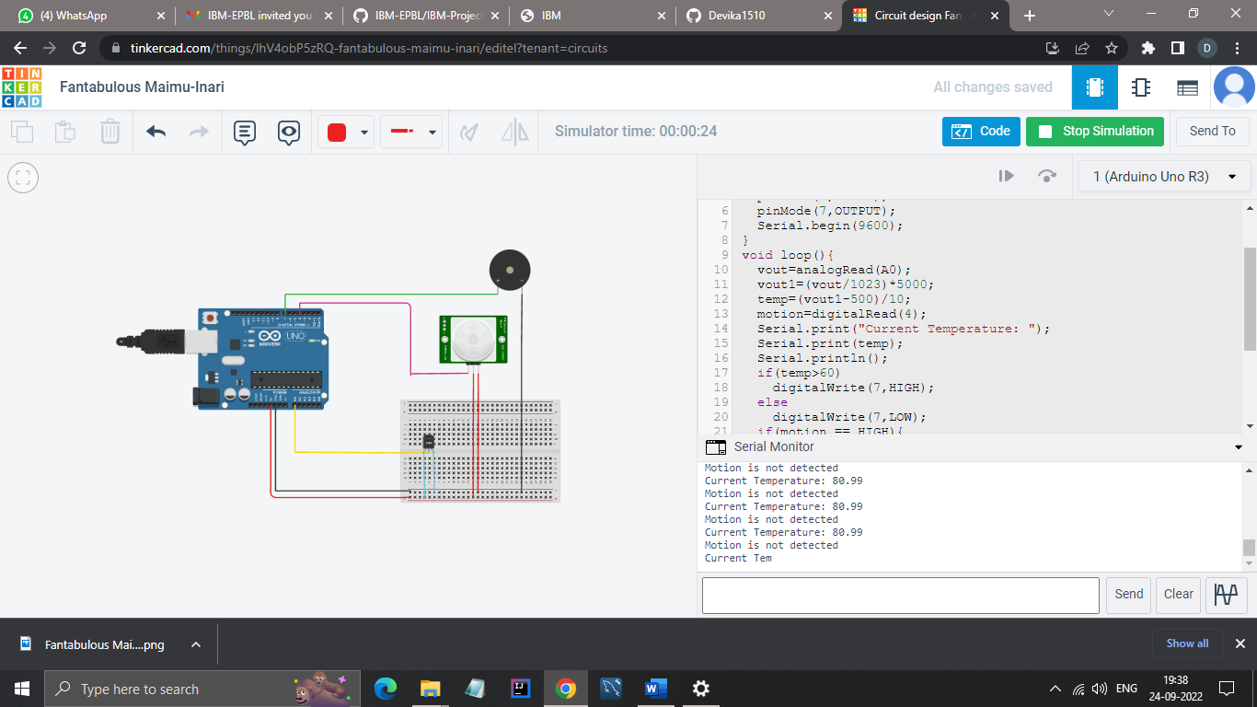

CODE

float vout,vout1,temp;

int motion=0;

void setup(){

pinMode(A0,INPUT);

pinMode(4,INPUT);

pinMode(7,OUTPUT);

Serial.begin(9600);

}

void loop(){

vout=analogRead(A0);

vout1=(vout/1023)\*5000;

temp=(vout1-500)/10;

motion=digitalRead(4);

Serial.print("Current Temperature: ");

Serial.print(temp);

Serial.println();

if(temp>60)

digitalWrite(7,HIGH);

else

digitalWrite(7,LOW);

if(motion == HIGH){

digitalWrite(7,HIGH);

Serial.println("Motion is detected");

}

else{

digitalWrite(7,LOW);

Serial.println("Motion is not detected");

}

delay(1000);

}